DWDM Lab Model Exam

Roll no.: 18BCS087

Name: Ashwin Pranaav K S

1. **Download a sample dataset from any Repository. List the attributes and its type in a word Doc.**

Dataset: Iris.csv

**Attributes and type:**

* Id – Numeric (Ordinal)
* SepalLengthCm – Numeric (Continuous)
* SepalWidthCm – Numeric (Continuous)
* PetalLengthCm – Numeric (Continuous)
* PetalWidthCm – Numeric (Continuous)
* Species – Categorical

1. **Create a random dataset of 30 elements with x and y variables using random function between 30 to 80 integers for x and 60 to 100 integers for y. Apply K- means clustering to cluster the data into 2 clusters. Plot the graph and display the result. Use Tkinter GUI to Display the Results**

**Importing essential libraries:**

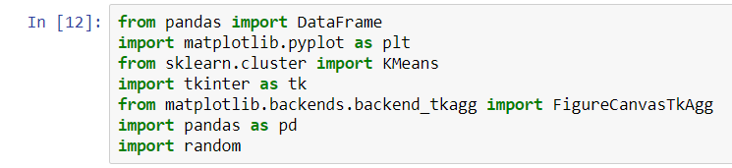

**Generating x list:**

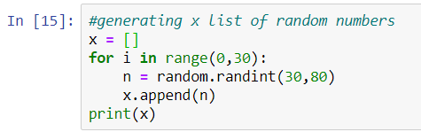



**Generating y list:**

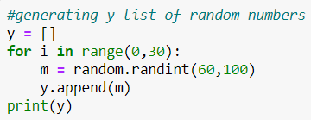



**Generating a dataframe containing x and y as attributes:**

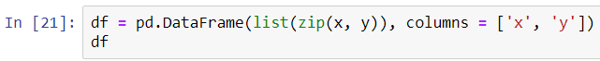

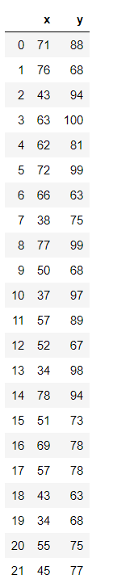

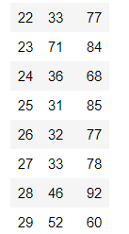

**Implementing K-means clustering:**

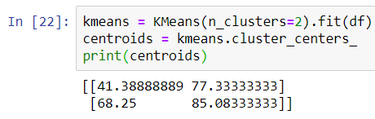

**Using Matplotlib for showing the result:**

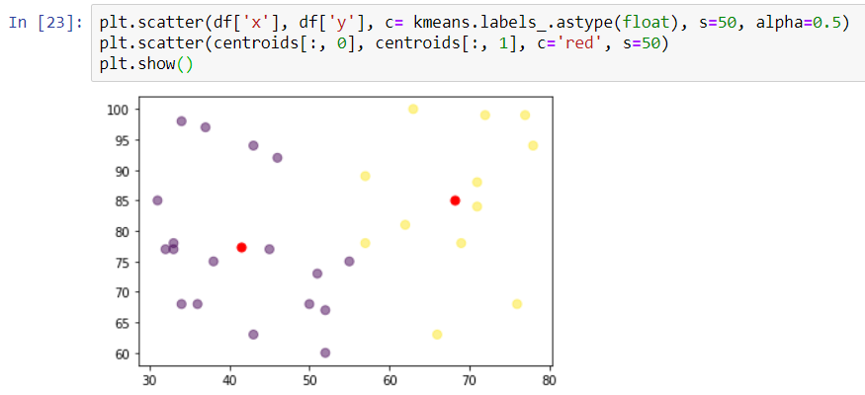

**Using TKinter for showing in a GUI:**

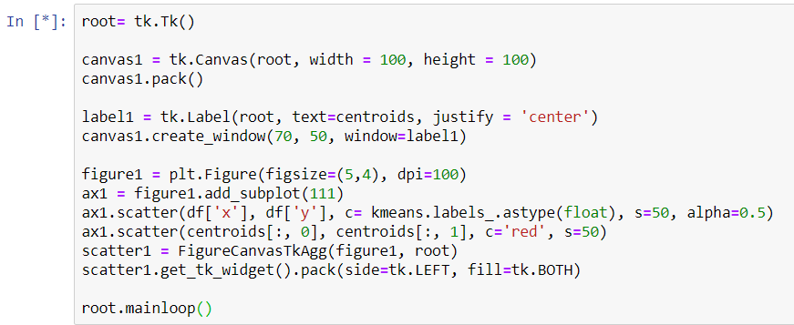

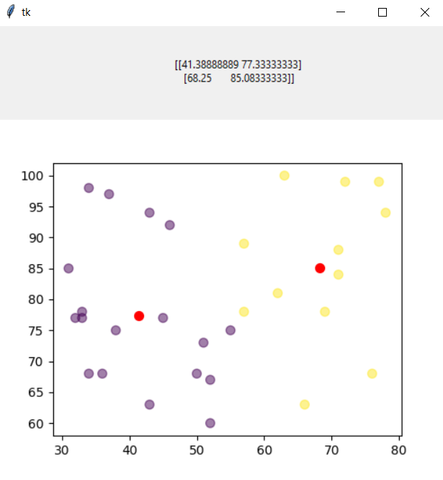

**3. Upload in your github account. Provide the link for access**

<https://github.com/AshwinPranaav/18BCS087-DWDM-model/>